Rev 4-1-22

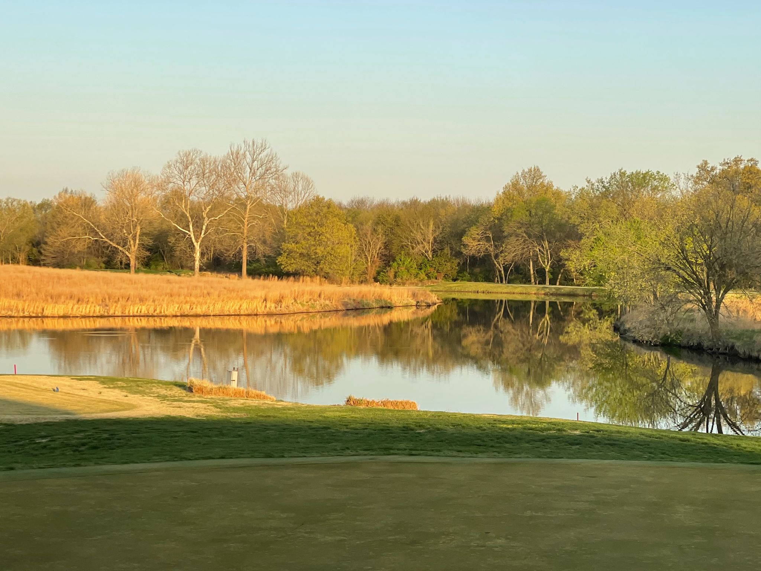

Crestwood Country Club

Catering Guide

John Hunter Head Chef

304 west Crestwood Avenue

Pittsburg, KS 66762

(620)231-9697

Crestwood Country Club is the place that can host your event. No matter the size, from small to large, we can accommodate.

Crestwood Country Club has the facilities to rival anywhere in the SEK Area. We can host events ranging from 20-300. (Smaller events are available upon request.) Our Clubhouse is wide open, and with space enough to comfortably hold your event. Our grounds around the Club are available, and provide potentially breathtaking views and additional event venues.

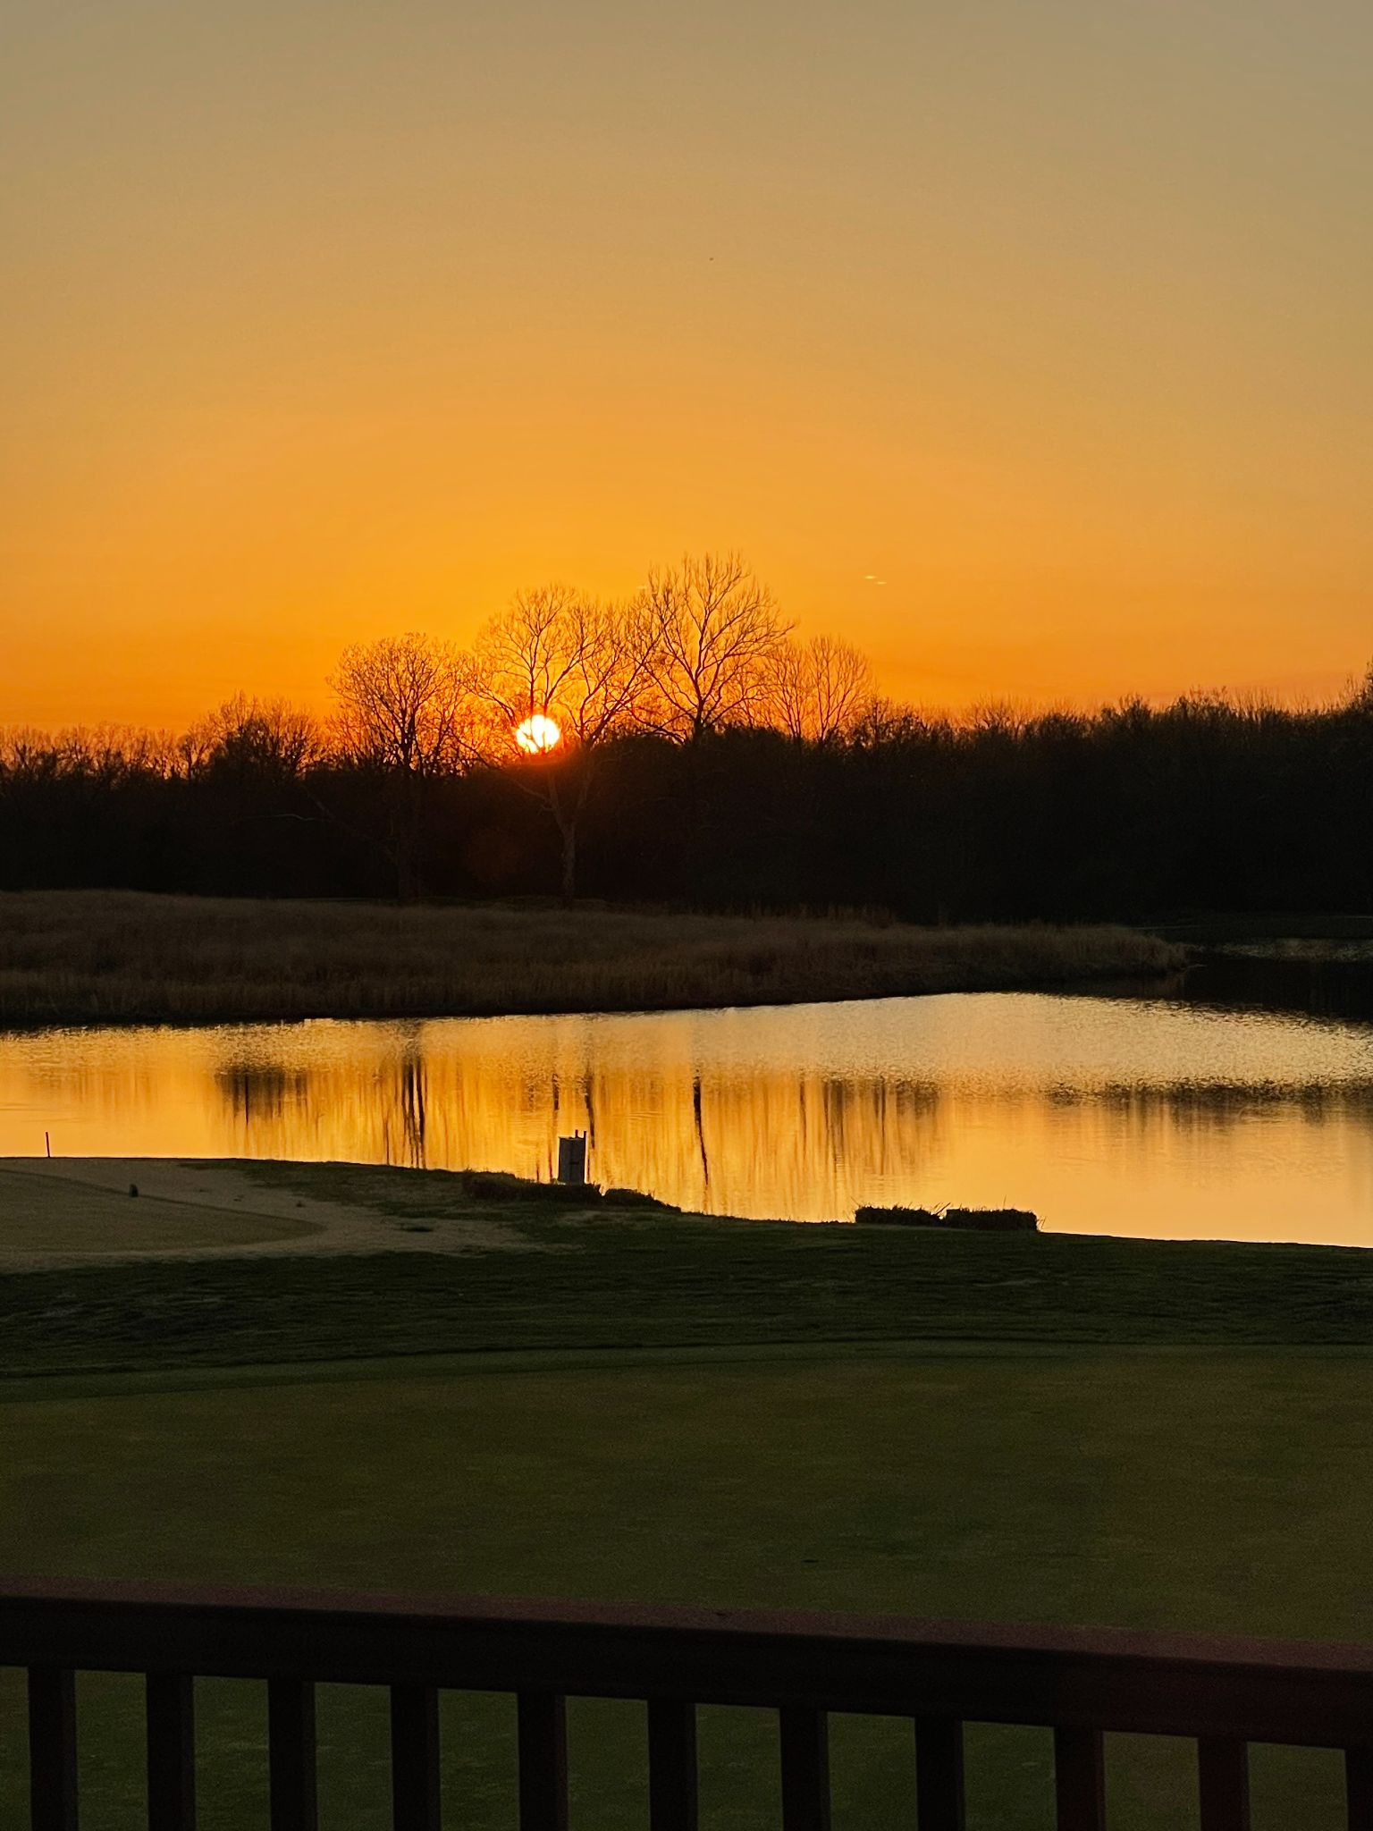

Our **Legends Boardroom** is a

Great private space for 30 people or less.

The **Pavilion** provides an excellent area for our dance floor, and a beautiful Reception area. It is an excellent area for Day-Time business meetings, and for the late nights Wedding Receptions.

**Private Rooms are available for any size group from 30-300.** This allows for more privacy, we have curtain walls, we can close to customize the room, and space needed. We are extremely accommodating in the aspect the party size is customizable. We would prefer to do plated food options for smaller parties (20 and below).

**Crestwood Country Club, can provide: Linens, China, Tableware, and Glassware and etc.** Any Food and Beverage equipment owned by

Crestwood can be available for use at your event. Any additional supplies or equipment would be brought in at your expense. Any damage to equipment or facilities would be your responsibility.

**Our facilities are event ready and decorated. However, guests can bring in their own decorations as long as it doesn’t require removal and storage of Crestwood décor/equipment.**

Help can be provided with set up and break down.Our staff can help assist with setting up and break down any decor or decorations needed for the event. There may be a charge in the form of a room fee for any exceptional setup or special room arrangements.

**Buffets are available for parties of 20 or more.** Parties with less than 20 people we would prefer to do a plated food option. Buffets available upon request.

Every event can be different in its location, theme, décor, menu, budget, bar service, room and

table setup and more. In this guide we cover policies, prices, fees and even suggest specific menus. These are just starting points and suggestions. We can modify suggested menus or

let us know what you want and we will create your own custom menu.

MENUS AND ROOM FEES AND ARRANGEMENTS WILL BE FINALIZED IN OUR PLANNING MEETINGS

Buffet Options

All quoted food pricing is good for 45 days and at that point is under review. We are doing our best to hold our pricing while trying to navigate increasing cost from our vendors.

BREAKFAST BUFFET- $11

A hearty southern style Breakfast Buffet that includes:

Scrambled Eggs, Bacon, Sausage Patties, Biscuits, Fried Potatoes, Yogurt Bar. (Granola, Yogurt, Berries). Orange Juice, Coffee, Tea. Milk Upon Request.

**Continental Breakfast Buffet - $8**

The Continental is focused on the Business Meetings with lighter options to accommodate the meeting, and on the go. The Continental Breakfast Buffet includes: Blueberry Muffins, Chocolate Chip Muffins, A variety of Bagels, with Cream Cheese. This option also includes: Coffee, Tea, Orange Juice.

Milk upon request

**Crestwood Standard Buffet**

This has become our most popular Buffet Option for the Day-Time meetings, and smaller events. It provides a nice variety of options, we are able to customize anything for the event. The price includes two (2) entree options. **$16/person**

Includes: Mixed Tossed Salad, Rolls, Potatoes, Green Beans, Two (2) Entrees, Coffee, Tea, Water. (Soda add $1 to Price/Person multiplied by the total number of guest at the event)

**Entree Options:**

Chicken Marsala

Grilled Chicken Breast, with Garlic Basil Sauce

Pasta Alfredo

Pasta with Meat Marinara

Fried Cod

Chopped Sirloin with mushrooms and onions

**The Crestwood Grande Buffet**

A true feast! A customizable buffet with: Coffee, Iced Tea, and Water. (Soda available for an additional $1/person multiplied by the total number of guest at the event)

Each option includes: Full Salad Bar, Rolls with Butter, choice of Vegetable, choice of two starches, choice of Entrees, choice of Dessert

2 - Entree Dinner - $23.00/person

3 - Entree Dinner - $28.00/person

**Vegetable options for the Grande Buffet:**

Green Beans with Bacon and Onions

Green Beans Almondine

Sugar Snap Peas

Seasonal Vegetable Medley

Fresh Broccoli

**Starches:**

Roasted Red Potatoes

Cheesy potatoes

Roasted Garlic Mashed Potatoes

Mashed Sweet Potatoes

Scalloped Potatoes

**Seafood:**

Seared Salmon

Breaded Catfish Fillets

Fried Cod

**Poultry:**Chicken Marsala

Marinated Grilled Chicken Breast

Chicken & Basil Garlic Beurre Blanc

Chicken parmesan

**Beef & Pork:**

Oven Roasted Pork Loin

Steak Tips

Shredded Chicken or Pulled Pork

Chopped Sirloin with mushrooms and onions

**Crestwood Appetizer Buffets**

For our smaller and more informal events, the Appetizer Buffet is an excellent option. We offer two (2) Appetizer Buffets.

**The 19th Hole Appetizer Buffet $14/Person**

A great assortment of standard Appetizers with the choice of two more options from the Appetizer A La Carte Menu. The 19th Hole Appetizer Buffet includes: Queso, Salsa, Homemade Tortilla Chips, Southwest Chicken Skewers, Choice of two (2) from A La Carte.

**The Grande Appetizer Buffet** **$19/Person**

A much Larger assortment of our Appetizers with the Choice of three more options for the Appetizer A La Carte Menu. The Grande Appetizer Buffet includes: Queso, Salsa, Homemade Chips, Crudites, Mini Ham and Turkey Sandwiches, and Chicken chunks, Choice of three (3) from A la Carte.

**Appetizer A La Carte Menu**

Domestic Cube Cheese Tray

Seasonal Vegetable Tray

Fresh Fruit Display

Hot Crab Dip

Chicken Tenders

Crestwood Queso

Spinach Artichoke Dip

Chips & Salads

Charcuterie Board

Shrimp Cocktail can be added to our appetizer buffets at a price per pound (market price)

**Charcuterie Boards**

Our Charcuterie Boards feature a mixture of products; nuts, fruit, crackers, cheeses, pretzels, meats, olives and other depending on the season and product availability.

10 pound board that provides a nice starter/appetizer for approximately 25 people- $150.00

Larger groups can be served at similar price per pound rate.

**Crestwood Country Club Themed Buffets:**

Themed buffets include coffee, tea and water. Soda drinks can be added for $1.00 per person

multiplied by the total number of guest at the event.

**Italian - $17.00**

Spaghetti Noodles, Fettuccine Noodles, Meaty Marinara, Alfredo Sauce, Grilled Chicken, Garlic Breadsticks, Tossed House Salad, Cookies.

**Barbecue - $23.00 / $30.00**

Smoked Sausage, Pulled Pork or Shredded Chicken, Pulled Pork Sliders, BBQ Chicken, Baked Beans, Potato Salad, and Potato Chips, Apple Pie. Additional we can add BB Brisket, and Coleslaw.

**Mexican - $15.00**

Hard, and Soft shell Tacos, Ground Beef, Lettuce, Tomatoes, Onions, Shredded Cheddar, Refried Beans, Chips, and Salas, with Cookies. Shredded Chicken (+$2), Carne Asada (+$4)

**Midwest Select - $18.00**

Steak Tips Topped with Mushrooms, and Onions, Brown Gravy, Grilled Chicken Breast, Scalloped Potatoes, Tossed House Salad, Rolls, Cookies.

**Crestwood Cookout - $15.00**

Hamburgers, Hot dogs, Potato Salads, Baked Beans, Potato Chips, Cookies

**Deli Buffet - $14.00**

Sliced Ham, Turkey and Cheese, Bread, Chips, baked beans, Tossed Salad, Cookies

**Family Fun Buffet - $16.00**

Pizza, Chicken Tenders, French Fries, Tossed Salad, Cookies

**Burger Bar - $13.00**

Grilled Burgers, Cheese, French Fries, Tossed Salad, Cookies

**Business Meetings**

*Coffee, Tea, Water Station -- $2.50 per person.

*Continental Breakfast can be arranged --?

*Donuts and or muffins can be arranged--?

*Break time snack can be arranged --?

*Lunch or Dinner can be arranged from our All Occasions Menu or our Dinner Menu

or one of our buffet options.

**Policies and Information**

1. Regular Hours of operation are 11am-2pm Wednesday through Friday for lunch service in the Lounge. Dinner Service is 5:00pm-9:00pm Wednesday through Saturday.
2. Crestwood Country Club is a private, non profit organization. No Advertisement or Public Solicitation for attendance may be made. **All events must be by invitation of a member only.**
3. An 15% Service charge and sales tax applies to all Food and Beverage ordered through Crestwood Country Club.
4. All events are subject to a deposit of 50% of the anticipated Final Bill, due at least 1 week before the event. Remainder of Payment due at conclusion of Event.
5. All Event Reservations must be cancelled at least 48 hours in advance on weekday events, and 72 for weekend events. Failure to do so will forfeit the deposit
6. Crestwood reserves the right to maintain and oversee all private parties, meetings, and receptions held on the premises.
7. **NO OUTSIDE FOOD OR DRINK.** All Food and Beverages must be purchased through Crestwood Country Club. Unless specified. **NO OUTSIDE LIQUOR, WINE, or BEER.** This violates the Country Club Bi-Laws and local Liquor Laws.
8. **A $1 per person plating fee could apply to wedding and other specialty**

**Cakes or baked goods that are not purchased from the club. These**

**must be pre-approved.**

1. Crestwood Country Club, reserves the right to determine the capacities of all meeting rooms. Crestwood Country Club will comply fully with all CDC, Health Department, Fire, and Safety regulations.
2. **Crestwood Country Club, is not responsible for lost or stolen merchandise, or items left in the club before and after the event.**
3. Any expenses incurred toward replacement or repair of goods, lost, or damaged by event guests will be added to the Final Bill.
4. Crestwood Country Club Reserves the right to move the event to a different room.
5. Functions held during non-operating hours, must meet a $500 minimum, Functions that do not meet this will be charged a “Facility Usage Fee”
6. Crestwood Country Club does not allow Confetti. Paper or plastic. A service fee of $50 - $1000 may apply to special events requiring more staff or furniture removal than normally necessary.
7. In the unlikely event Crestwood Country Club has to rent additional supplies, a fee will be added to the Final Bill.
8. Crestwood Country Club, will adhere to all Local and Federal liquor Laws. Any violation will result in termination of the event and the deposit will be kept.
9. All bands and DJs times must be approved by the Crestwood Country Club Management, unless the event has been granted a Clubhouse Closure.
10. **A Clubhouse Closure requires a vote by the Board of Directors and is subject to a closure fee of $500.00 or more depending on the circumstances of the event.**
11. To-Go boxes can be purchased for buffet items, for a nominal fee, added to the Final Bill.
12. Seasonal Menu Items are subject to change with notice.
13. Any arrangements for linens must be made at least two weeks in advance. There may be a Tablecloth charge of $2 per table if an event does not meet a minimum spending level that compensates for linen use.
14. A dancefloor is available for a rental fee of $150 for use.